Activity sheet 2. New York Rambling

1. **Humans**

* The ‘experience’ for you, the ‘viewer ‘in *New York Rambling* installation was a core value during the planning and execution of work. In your view how does the ‘absence of humans’ effect the experience for the viewer?
* Identify panel “b” in the exhibit from the thumbnail supplied.

List up to three or more objects, which uses the strength or interaction of a human. There are many.

1. 2. 3. 4.

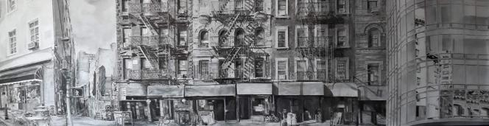

1. **Landmarks**

Landmarks are prominent or well-known features in an environment, a feature that stands out from its near environment and is often visible from long distances

Identify:

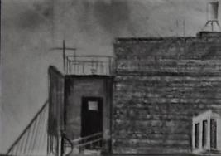

* Which panel this section is taken from?
* What is this well-walked landmark in New York?

1. **Atmosphere**

Tone, light, shape, sound and texture are often combined to interpret or create atmospheres. Mark Rothko created paintings with a defined atmosphere or mood, Brian Eno created atmospheric soundscapes for art installations. Claude Monet and Turner painted work in response to specific atmospheric conditions.

Name two ways in which atmosphere has been captured and is evident in *New York Rambling*