**Activity Answer** sheet 1. New York Rambling

1. **Look and find:**

(These items can be found on one or more panels)

* A bicycle or two______B________ ________________________________
* A pedestrian crossing_______A, B,D______________________________________
* A washing line (hint : rooftop)______D____________________________________
* A ferry_________C_____________________________________________________
* Net curtains______A,B,F________________________________________________
* A place to have a coffee___B_____________________________________________
* Traffic lights___C,D_______________________________________________________

1. **Name the panel where you can find the images below:**

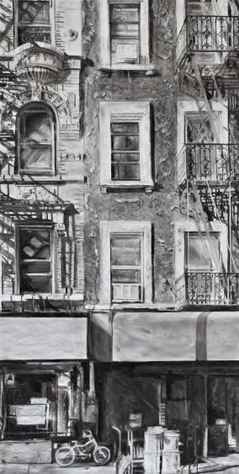

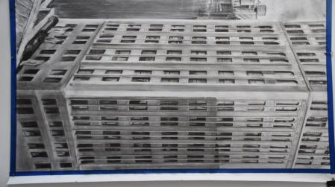

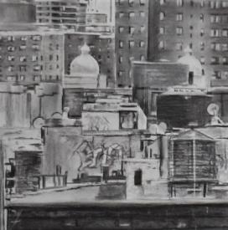

**D**

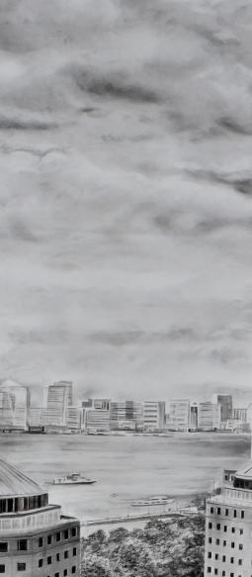

**E**

**C**

**F**

**E**

**B**

